Chapter 15. Building an API

In the previous chapter, you built a system for student registration and enrollment in courses. You created views to display course contents and learned how to use Django’s cache framework.

In this chapter, you will create a RESTful API for your e-learning platform. An API is a common programmable interface that can be used on multiple platforms like websites, mobile applications, plugins, and so on. For example, you can create an API to be consumed by a mobile application for your e-learning platform. If you provide an API to third parties, they will be able to consume information and operate with your application programmatically. An API allows developers to automate actions on your
platform and integrate your service with other applications or online services. You will build a fully featured API for your e-learning platform.

In this chapter, you will:
- Install Django REST framework
- Create serializers for your models
- Build a RESTful API
- Implement serializer method fields
- Create nested serializers
- Implement ViewSet views and routers
- Build custom API views
- Handle API authentication
- Add permissions to API views
- Create custom permissions
- Use the Requests library to consume the API

Functional overview
Figure 15.1 shows a representation of the views and API endpoints that will be built in this chapter:
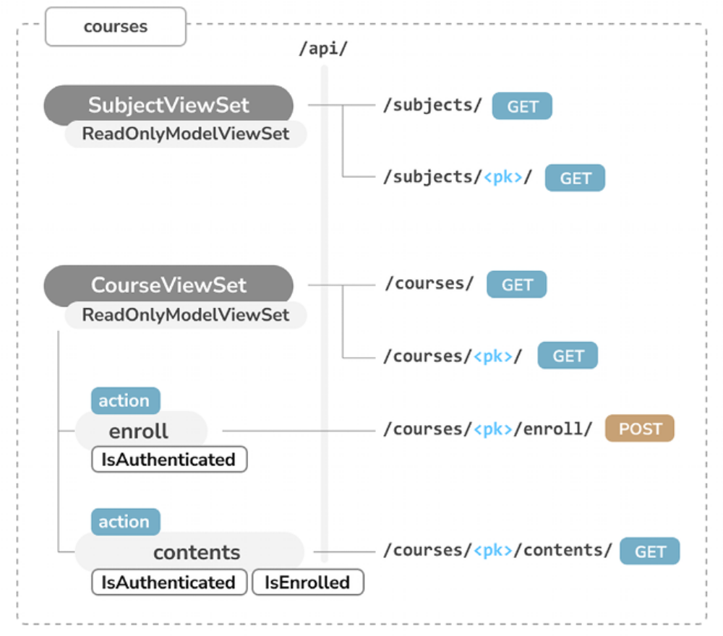
Figure 15.1: Diagram of API views and endpoints to be built in Chapter 15

In this chapter, you will create two different sets of API views, SubjectViewSet and CourseViewSet . The former will include the list and detail views for subjects. The latter will include the list and detail views for courses. You will also implement the enroll action in CourseViewSet to enroll students in courses. This action will be only available to authenticated users, by using the IsAuthenticated permission. You will create the contents action in CourseViewSet to access a course’s content. To access course contents, users have to be authenticated and enrolled in the given course. You will implement the custom IsEnrolled permission to limit access to contents to the users enrolled in the course.

If you are not familiar with API endpoints, you just need to know that they are the specific locations within an API that accept and respond to requests. Each endpoint corresponds to a URL that may accept one or more HTTP methods, like GET , POST , PUT , or DELETE .

The source code for this chapter can be found at
https://github.com/PacktPublishing/Django-5-byexample/tree/main/Chapter15.

All Python modules used in this chapter are included in the requirements.txt file in the source code that accompanies this chapter. You can follow the instructions to install each Python module below, or you can install all requirements at once with the command python -m pip install - r requirements.txt .

Building a RESTful API
When building an API, there are several ways you can structure its endpoints and actions, but following REST principles is encouraged.

The REST architecture comes from Representational State Transfer. RESTful APIs are resource-based; your models represent resources, and HTTP methods such as GET , POST , PUT , or DELETE are used to retrieve, create, update, or delete objects. HTTP response codes are also used in this context. Different HTTP response codes are returned to indicate the result of the HTTP request, for example, 2XX response codes for success, 4XX for errors, and so on.

The most common formats to exchange data in RESTful APIs are JSON and XML. You will build a RESTful API with JSON serialization for your project. Your API will provide the following functionalities:

- Retrieving subjects
- Retrieving available courses
- Retrieving course contents
- Enrolling in a course

You can build an API from scratch with Django by creating custom views. However, there are several third-party modules that simplify creating an API for your project; the most popular among them is Django REST framework (DRF).

DRF provides a comprehensive set of tools to build RESTful APIs for your projects. The following are some of the most relevant components that we will use to build our API:

- Serializers: To transform data into a standardized format that other programs can understand, or to deserialize data, by converting data into a format that your program can process.

- Parsers and renderers: To render (or format) serialized data appropriately before it is returned in an HTTP response. Similarly, to parse incoming data to ensure that it’s in the correct form.

- API views: To implement the application logic.

- URLs: To define the API endpoints that will be available.

- Authentication and permissions: To define authentication methods for the API and the permissions required for each view.

We will start by installing DRF and, after that, we will learn more about these components to build our first API.

Installing Django REST framework
You can find all the information about DRF at https://www.djangorest-framework.org/.

Open the shell and install the framework with the following command:
python -m pip install djangorestframework==3.15.1

Edit the settings.py file of the educa project and add rest_framework to the INSTALLED_APPS setting to activate the application, as follows:
INSTALLED_APPS = [
# ...
'rest_framework',
]

Then, add the following code to the settings.py file:
REST_FRAMEWORK = {
'DEFAULT_PERMISSION_CLASSES': [
'rest_framework.permissions.DjangoModelPermissionsOrAnon
]
}

You can provide a specific configuration for your API using the REST_FRAMEWORK setting. DRF offers a wide range of settings to configure default behaviors. The DEFAULT_PERMISSION_CLASSES setting specifies the default permissions to read, create, update, or delete objects. You set DjangoModelPermissionsOrAnonReadOnly as the only default permission
class. This class relies on Django’s permissions system to allow users to create, update, or delete objects while providing read-only access for anonymous users. You will learn more about permissions later, in the Adding permissions to views section.

For a complete list of available settings for DRF, you can visit
https://www.django-rest-framework.org/apiguide/settings/.

Defining serializers
After setting up DRF, you need to specify how your data will be serialized. Output data has to be serialized in a specific format, and input data will be deserialized for processing. The framework provides the following classes to build serializers for single objects:

- Serializer : Provides serialization for normal Python class instances

- ModelSerializer : Provides serialization for model instances

- HyperlinkedModelSerializer : The same as ModelSerializer , but it represents object relationships with links rather than primary keys

Let’s build our first serializer. Create the following file structure inside the courses application directory:
api/
__init__.py
serializers.py

You will build all the API functionality inside the api directory to keep everything well organized. Edit the api/serializers.py file and add the following code:
from rest_framework import serializers
from courses.models import Subject
class SubjectSerializer(serializers.ModelSerializer):
class Meta:
model = Subject
fields = ['id', 'title', 'slug']

This is the serializer for the Subject model. Serializers are defined in a similar fashion to Django’s Form and ModelForm classes. The Meta class allows you to specify the model to serialize and the fields to be included for serialization. All model fields will be included if you don’t set a fields attribute.

Let’s try the serializer. Open the command line and start the Django shell with the following command:
python manage.py shell

Run the following code:
>>> from courses.models import Subject
>>> from courses.api.serializers import SubjectSerializer
>>> subject = Subject.objects.latest('id')
>>> serializer = SubjectSerializer(subject)
>>> serializer.data
{'id': 4, 'title': 'Programming', 'slug': 'programming'}

In this example, you get a Subject object, create an instance of SubjectSerializer , and access the serialized data. You can see that the model data is translated into Python native data types.

You can read more about serializers at
https://www.django-restframework.org/api-guide/serializers/.

Understanding parsers and renderers
The serialized data has to be rendered in a specific format before you return it in an HTTP response. Likewise, when you get an HTTP request, you have to parse the incoming data and deserialize it before you can operate with it.
DRF includes renderers and parsers to handle that.

Let’s see how to parse incoming data. Execute the following code in the
Python shell:
>>> from io import BytesIO
>>> from rest_framework.parsers import JSONParser
>>> data = b'{"id":4,"title":"Programming","slug":"programming"}'
>>> JSONParser().parse(BytesIO(data))
{'id': 4, 'title': 'Programming', 'slug': 'programming'}
Given a JSON string input, you can use the JSONParser class provided by DRF to convert it to a Python object.

DRF also includes Renderer classes that allow you to format API responses. The framework determines which renderer to use through content negotiation by inspecting the request’s Accept header to determine the expected content type for the response. Optionally, the renderer is determined by the format suffix of the URL. For example, the URL http://127.0.0.1:8000/api/data.json might be an endpoint that triggers the JSONRenderer in order to return a JSON response.

Go back to the shell and execute the following code to render the
serializer object from the previous serializer example:
>>> from rest_framework.renderers import JSONRenderer
>>> JSONRenderer().render(serializer.data)

You will see the following output:
b'{"id":4,"title":"Programming","slug":"programming"}'

You use the JSONRenderer to render the serialized data into JSON. By default, DRF uses two different renderers: JSONRenderer and BrowsableAPIRenderer . The latter provides a web interface to easily browse your API. You can change the default renderer classes with the DEFAULT_RENDERER_CLASSES option of the REST_FRAMEWORK setting.

You can find more information about renderers and parsers at
https://www.django-rest-framework.org/apiguide/renderers/ and
https://www.django-restframework.org/api-guide/parsers/, respectively.

Next, you are going to learn how to build API views and use serializers in views.

Building list and detail views
DRF comes with a set of generic views and mixins that you can use to build your API views. You have been using generic views throughout this book since Chapter 2, Enhancing Your Blog and Adding Social Features, and you learned about mixins in Chapter 13, Creating a Content Management System.

The base views and mixins provide the functionality to retrieve, create, update, or delete model objects. You can see all the generic mixins and views provided by DRF at https://www.django-restframework.org/api-guide/generic-views/.

Let’s create list and detail views to retrieve Subject objects. Create a new file inside the courses/api/ directory and name it views.py . Add the following code to it:
from rest_framework import generics
from courses.api.serializers import SubjectSerializer
from courses.models import Subject
class SubjectListView(generics.ListAPIView):
queryset = Subject.objects.all()
serializer_class = SubjectSerializer
class SubjectDetailView(generics.RetrieveAPIView):
queryset = Subject.objects.all()
serializer_class = SubjectSerializer

In this code, you use the generic ListAPIView and RetrieveAPIView views of DRF. Both views have the following attributes:

- queryset : The base QuerySet to use to retrieve objects

- serializer_class : The class to serialize objects

Let’s add URL patterns for your views. Create a new file inside the courses/api/ directory, name it urls.py , and make it look as follows:
from django.urls import path
from . import views
app_name = 'courses'
urlpatterns = [
path(
'subjects/',
views.SubjectListView.as_view(),
name='subject_list'
),
path(
'subjects/<pk>/',
views.SubjectDetailView.as_view(),
name='subject_detail'
),
]

In the URL pattern for the SubjectDetailView view, you include a pk URL parameter to retrieve the object with the given primary key of the Subject model, which is the id field. Edit the main urls.py file of the educa project and include the API patterns, as follows:
urlpatterns = [
# ...
path('api/', include('courses.api.urls', namespace='api')),
]

You use the api namespace for your API URLs. Our initial API endpoints are ready to be used.

Consuming the API
By making our views available via URLs, we have created our first API endpoints. Let’s now try our own API. Ensure that your server is running with the following command:
python manage.py runserver

We are going to use curl to consume the API. curl is a command-line tool that allows you to transfer data to and from a server. If you are using Linux, macOS, or Windows 10/11, curl is very likely included in your system.
However, you can download curl from https://curl.se/download.html.

Open the shell and retrieve the URL http://127.0.0.1:8000/api/subjects/ with curl , as follows:
curl http://127.0.0.1:8000/api/subjects/

You will get a response similar to the following one:
[
{
"id":1,
"title":"Mathematics",
"slug":"mathematics"
},
{
"id":2,
"title":"Music",
"slug":"music"
},
{
"id":3,
"title":"Physics",
"slug":"physics"
},
{
"id":4,
"title":"Programming",
"slug":"programming"
}
]

To obtain a more readable, well-indented JSON response, you can use curl with the json_pp utility, as follows:
curl http://127.0.0.1:8000/api/subjects/ | json_pp

The HTTP response contains a list of Subject objects in the JSON format.

Instead of curl , you can also use any other tool to send custom HTTP requests, including a browser extension such as Postman, which you can get at https://www.getpostman.com/.

Open http://127.0.0.1:8000/api/subjects/ in your browser. You will see DRF’s browsable API, as follows:
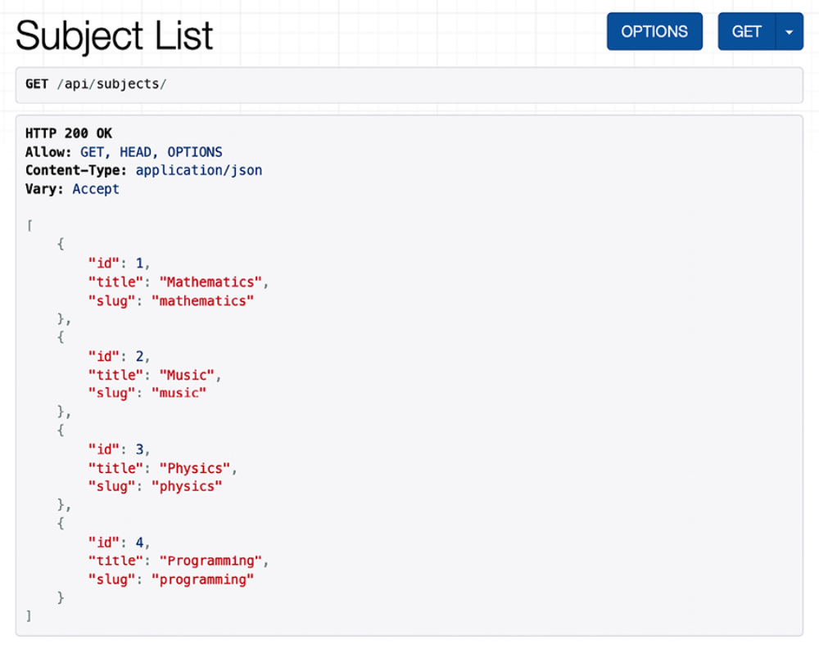
Figure 15.2: The Subject List page in the REST framework browsable API

This HTML interface is provided by the BrowsableAPIRenderer renderer. It displays the result headers and content, and it allows you to perform requests. You can also access the API detail view for a Subject object by including its ID in the URL.

Open http://127.0.0.1:8000/api/subjects/1/ in your browser. You will see a single Subject object rendered in the JSON format.
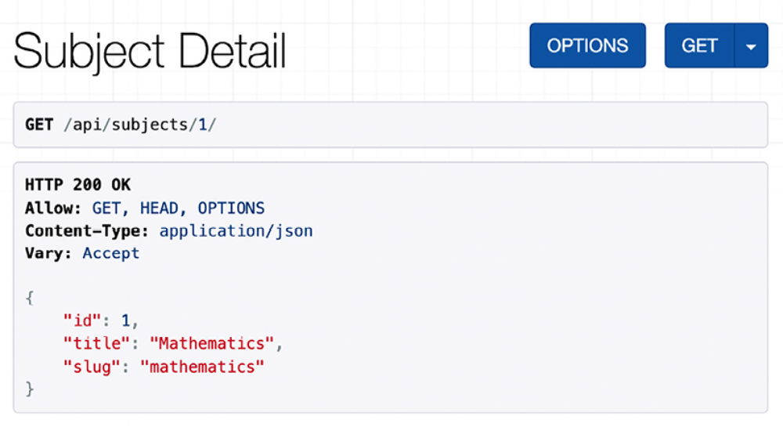
Figure 15.3: The Subject Detail page in the REST framework browsable API

This is the response for the SubjectDetailView . Let’s learn how to enrich the content returned for each subject. In the next section, we are going to dive into extending serializers with additional fields and methods.

Extending serializers
You have learned how to serialize your model objects; however, often, you may want to enrich the response with additional relevant data or calculated fields. Let’s take a look at some of the options to extend serializers.

Adding additional fields to serializers
Let’s edit the subject views to include the number of courses available for each subject. You will use the Django aggregation functions to annotate the count of related courses for each subject.

Edit the api/views.py file of the courses application and add the following
code highlighted in bold:
from django.db.models import Count
# ...
class SubjectListView(generics.ListAPIView):
queryset = Subject.objects.annotate(total_courses=Count('cou
serializer_class = SubjectSerializer
class SubjectDetailView(generics.RetrieveAPIView):
queryset = Subject.objects.annotate(total_courses=Count('cou
serializer_class = SubjectSerializer

You are now using a QuerySet for the SubjectListView and SubjectDetailView that uses the Count aggregation function to annotate the related course count.

Edit the api/serializers.py file of the courses application and add the
following code highlighted in bold:
from rest_framework import serializers
from courses.models import Subject
class SubjectSerializer(serializers.ModelSerializer):
total_courses = seralizers.IntegerField()
class Meta:
model = Subject
fields = ['id', 'title', 'slug', 'total_courses']

You have added the total_courses field to the SubjectSerializer class. This field is an IntegerField to represent integers. This field will automatically get its value from the total_courses attribute of the object being serialized. By using annotate() , we added the total_courses attribute to the resulting objects of the QuerySet .

Open http://127.0.0.1:8000/api/subjects/1/ in your browser. The serialized JSON object now includes the total_courses attribute, as shown in Figure 15.4:
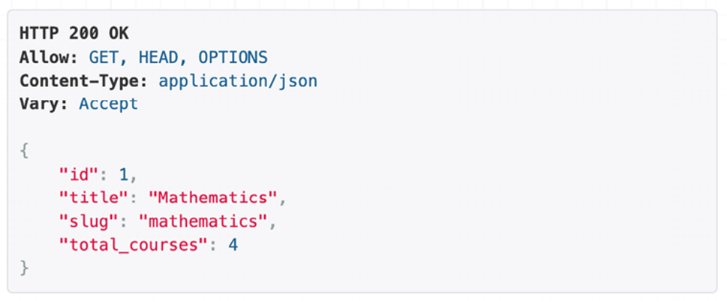
Figure 15.4: The Subject Detail page, including the total_courses attribute

You have successfully added the total_courses attribute to the subject list and detail views. Now, let’s look into adding additional attributes using custom serializer methods.

Implementing serializer method fields
DRF provides SerializerMethodField , which allows you to implement read-only fields that get their value by calling a method of the serializer class. This can be particularly useful when you want to include some custom formatted data in your serialized object or perform complex calculations that are not directly a part of your model instances.

We will create a method that serializes the top 3 popular courses for a subject. We will rank courses by the number of students enrolled in them.

Edit the api/serializers.py file of the courses application and add the
following code highlighted in bold:
from django.db.models import Count
from rest_framework import serializers
from courses.models import Subject
class SubjectSerializer(serializers.ModelSerializer):
total_courses = serializers.IntegerField()
popular_courses = seralizers.SerializerMethodField()
def get_popular_courses(self, obj):
courses = obj.courses.annotate(
total_students=Count('students')
).order_by('total_students')[:3]
return [
f'{c.title} ({c.total_students})' for c in courses
]
class Meta:
model = Subject
fields = [
'id',
'title',
'slug',
'total_courses',
'popular_courses'
]

In the new code, you add the new popular_courses serializer method field to SubjectSerializer . The field gets its value from the get_popular_courses() method. You can provide the name of the serializer method to call with the method_field argument of SerializerMethodField .
If not included, this defaults to get_<field_name> .

Open http://127.0.0.1:8000/api/subjects/1/ in your browser. The serialized JSON object now includes the total_courses attribute, as shown in Figure 15.5:
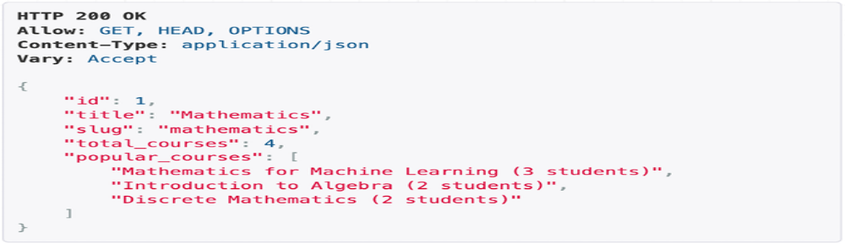
Figure 15.5: The subject detail page, including the popular_courses attribute
You have successfully implemented a SerializerMethodField . Note that, now, an additional SQL query is generated for each of the results returned by SubjectListView . Next, you are going to learn how to control the number of results returned by adding pagination to SubjectListView .

Adding pagination to views
DRF includes built-in pagination capabilities to control how many objects are sent over in your API responses. When the content of your site starts to grow, you might end up with a large number of subjects and courses. Pagination can be particularly useful to improve performance and the user experience when dealing with large datasets.

Let’s update the SubjectListView view to include pagination. First, we will define a pagination class.

Create a new file inside the courses/api/ directory and name it
pagination.py . Add the following code to it:
from rest_framework.pagination import PageNumberPagination
class StandardPagination(PageNumberPagination):
page_size = 10
page_size_query_param = 'page_size'
max_page_size = 50

In this class, we inherit from PageNumberPagination . This class provides support for pagination based on page numbers. We set the following attributes:

- page_size : Determines the default page size (the number of items returned per page) when no page size is provided in the request

- page_size_query_params : Defines the name for the query parameter to use for the page size

- max_page_size : Indicates the maximum requested page size allowed

Now, edit the api/views.py file of the courses application and add the following lines highlighted in bold:
from django.db.models import Count
from rest_framework import generics
from courses.models import Subject
from courses.api.pagination import StandardPagination
from courses.api.serializers import SubjectSerializer
class SubjectListView(generics.ListAPIView):
queryset = Subject.objects.annotate(total_courses=Count('cou
serializer_class = SubjectSerializer
pagination_class = StandardPagination
# ...

You can now paginate the objects returned by SubjectListView . Open http://127.0.0.1:8000/api/subjects/ in your browser. You can see that the JSON structure returned by the view is now different due to the pagination. You will see the following structure:
{
"count": 4,
"next": null,
"previous": null,
"results": [
{
"id": 1,
"title": "Mathematics",
...
},
...
]
}

The following items are now part of the JSON returned:

- count : The total number of results.

- next : The URL to retrieve the next page. The value is null when there are no following pages.

- previous : The URL to retrieve the previous page. The value is null when there are no previous pages.

- results : A list with the serialized objects returned on this page.

Open http://127.0.0.1:8000/api/subjects/?page_size=2&page=1 in your browser. This will paginate results by two items per page and retrieve the first page of results, as shown in Figure 15.6:
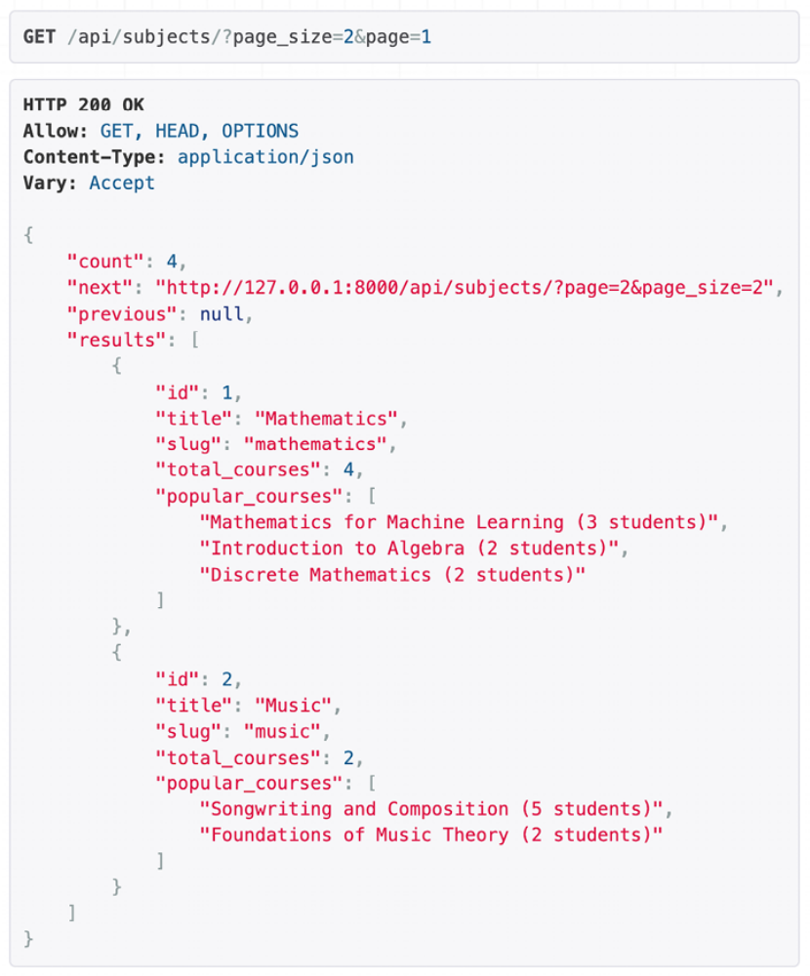
Figure 15.6: First page of results for the subject list pagination, with a page size of 2

We have implemented pagination based on the page number, but DRF also provides a class to implement limit/offset and cursor-based pagination. You can read more about pagination at https://www.django-restframework.org/api-guide/pagination/.

You have created the API endpoints for the subject views. Next, you will add course endpoints to your API.

Building the course serializer
We are going to create a serializer for the Course model. Edit the api/serializers.py file of the courses application and add the following code highlighted in bold:
# ...
from courses.models import Course, Subject
class CourseSerializer(serializers.ModelSerializer):
class Meta:
model = Course
fields = [
'id',
'subject',
'title',
'slug',
'overview',
'created',
'owner',
'modules'
]

Let’s take a look at how a Course object is serialized. Open the shell and execute the following command:
python manage.py shell

Run the following code:
>>> from rest_framework.renderers import JSONRenderer
>>> from courses.models import Course
>>> from courses.api.serializers import CourseSerializer
>>> course = Course.objects.latest('id')
>>> serializer = CourseSerializer(course)
>>> JSONRenderer().render(serializer.data)

You will get a JSON object with the fields that you included in CourseSerializer . You can see that the related objects of the modules manager are serialized as a list of primary keys, as follows:
"modules": [6, 7, 9, 10]

These are the IDs of the related Module objects. Next, you are going to learn different methods to serialize related objects.

Serializing relations
DRF comes with different types of related fields to represent model relationships. This works for ForeignKey , ManyToManyField , and OneToOneField relationships, as well as generic model relations.

We are going to use StringRelatedField to change how related Module objects are serialized. StringRelatedField represents the related object using its __str__() method.

Edit the api/serializers.py file of the courses application and add the
following code highlighted in bold:
# ...
class CourseSerializer(serializers.ModelSerializer):
modules = serializers.StringRelatedField(many=True, read_onl
class Meta:
# ...

In the new code, you define the modules field that provides serialization for the related Module objects. You use many=True to indicate that you are serializing multiple related objects. The read_only parameter indicates that this field is read-only and should not be included in any input to create or update objects.

Open the shell and create an instance of CourseSerializer again. Render the serializer’s data attribute with JSONRenderer . This time, the listed modules are serialized using their __str__() method, as follows:
"modules": ["0. Installing Django", "1. Configuring Django"]

Note that DRF does not optimize QuerySets. When serializing a list of courses, a SQL query will be generated for each course result to retrieve the related Module objects. You can reduce the number of additional SQL requests by using prefetch_related() in your QuerySet, like Course.objects.prefetch_related('modules') . We will cover this later in the section Creating ViewSets and routers.

You can read more about serializer relations at
https://www.djangorest-framework.org/api-guide/relations/.

Let’s advance further and define the serialization of related objects with a nested serializer.

Creating nested serializers
If we want to include more information about each module, we need to serialize Module objects and nest them. Modify the previous code of the api/serializers.py file of the courses application to make it look as follows:
from django.db.models import Count
from rest_framework import serializers
from courses.models import Course, Module, Subject
class ModuleSerializer(serializers.ModelSerializer):
class Meta:
model = Module
fields = ['order', 'title', 'description']
class CourseSerializer(serializers.ModelSerializer):
modules = ModuleSerializer(many=True, read_only=True)
class Meta:
# ...

In the new code, you define ModuleSerializer to provide serialization for the Module model. Then, you modify the modules attribute of CourseSerializer to nest the ModuleSerializer serializer. You keep many=True to indicate that you are serializing multiple objects and read_only=True to keep this field read-only.

Open the shell and create an instance of CourseSerializer again. Render the serializer’s data attribute with JSONRenderer . This time, the listed modules are serialized with the nested ModuleSerializer serializer, as follows:
"modules": [
{
"order": 0,
"title": "Introduction to overview",
"description": "A brief overview about the Web Framework."
},
{
"order": 1,
"title": "Configuring Django",
"description": "How to install Django."
},
...
]
Creating ViewSets and routers
ViewSets allow you to define the interactions of your API and let DRF build URLs dynamically with a Router object. By using ViewSets, you can avoid repeating logic for multiple views. ViewSets include actions for the following standard operations:

- Create operation: create()

- Retrieve operation: list() and retrieve()

- Update operation: update() and partial_update()

- Delete operation: destroy()

Let’s create a ViewSet for the Course model. Edit the api/views.py file and add the following code highlighted in bold:
from django.db.models import Count
from rest_framework import generics
from rest_framework import viewsets
from courses.api.pagination import StandardPagination
from courses.api.serializers import CourseSerializer, SubjectSer
from courses.models import Course, Subject
class CourseViewSet(viewsets.ReadOnlyModelViewSet):
queryset = Course.objects.prefetch_related('modules')
serializer_class = CourseSerializer
pagination_class = StandardPagination

The new CourseViewSet class inherits from ReadOnlyModelViewSet , which provides the read-only actions list() and retrieve() to list objects or retrieve a single object, respectively. You specify the base QuerySet to retrieve objects. You use prefetch_related('modules') to fetch the related
Module objects in an efficient manner. This will avoid additional SQL queries when serializing nested modules for each course. In this class, you also define the serializer and pagination classes to use for the ViewSet.

Edit the api/urls.py file and create a router for your ViewSet, as follows:
from django.urls import include, path
from rest_framework import routers
from . import views
app_name = 'courses'
router = routers.DefaultRouter()
router.register('courses', views.CourseViewSet)
urlpatterns = [
# ...
path('', include(router.urls)),
]

You create a DefaultRouter object and register CourseViewSet with the courses prefix. The router takes charge of generating URLs automatically for your ViewSet .

Open http://127.0.0.1:8000/api/ in your browser. You will see that the router lists the courses ViewSet in its base URL, as shown in Figure 15.7:
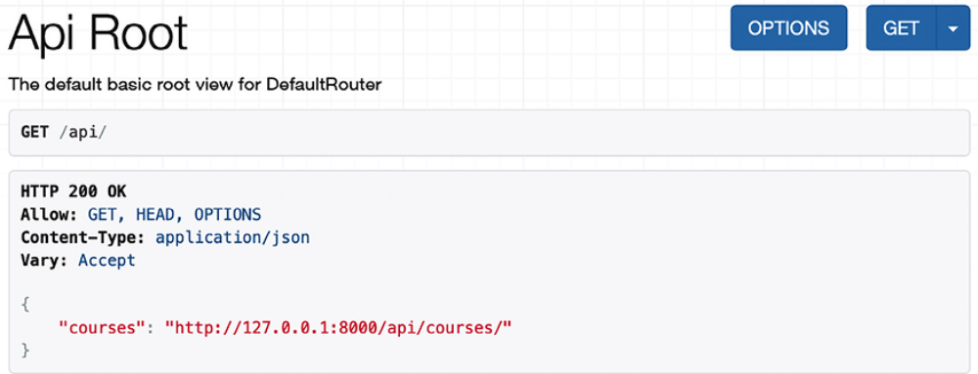
Figure 15.7: The API Root page of the REST framework browsable API

You can access http://127.0.0.1:8000/api/courses/ to retrieve the list of courses, as shown in Figure 15.8:
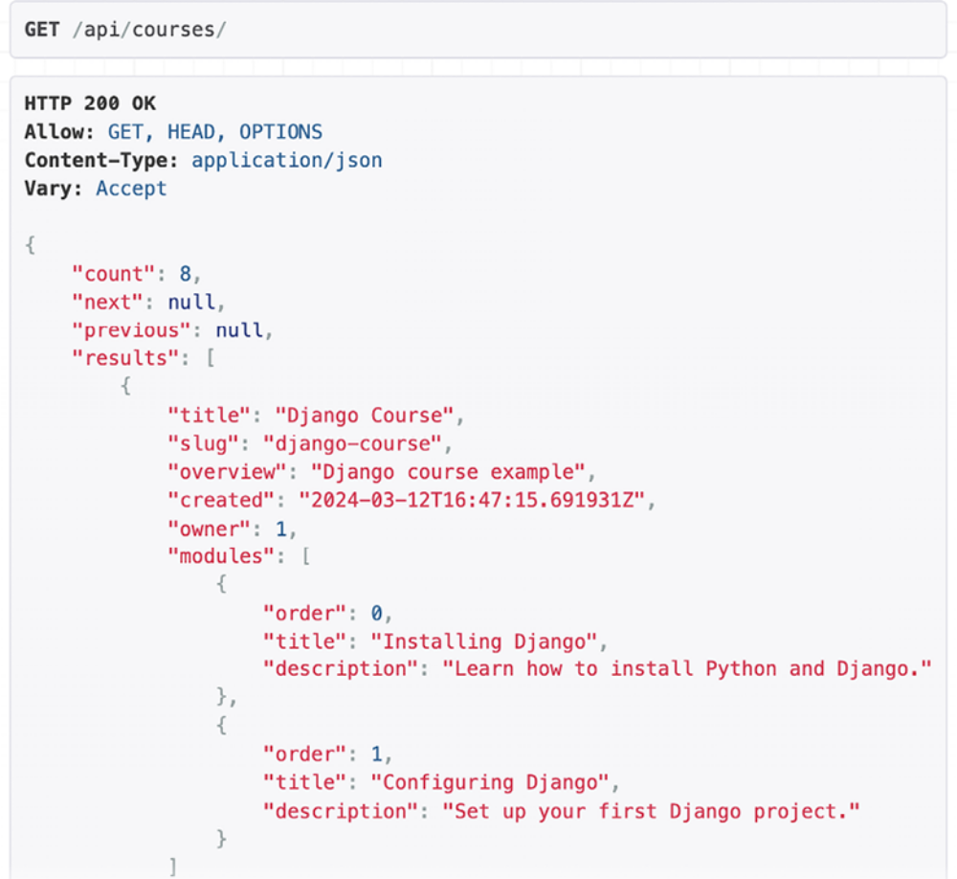
Figure 15.8: The Course List page in the REST framework browsable API
Let’s convert the SubjectListView and SubjectDetailView views into a single ViewSet. Edit the api/views.py file, and remove or comment out the SubjectListView and SubjectDetailView classes. Then, add the following code highlighted in bold:
# ...
class SubjectViewSet(viewsets.ReadOnlyModelViewSet):
queryset = Subject.objects.annotate(total_courses=Count('cou
serializer_class = SubjectSerializer
pagination_class = StandardPagination

Edit the api/urls.py file and remove or comment out the following URLs, since you don’t need them anymore:
# path(
# subjects/',
# views.SubjectListView.as_view(),
# name=subject_list'
# ),
# path(
# subjects/<pk>/ ',
# views.SubjectDetailView.as_view(),
# name='subject_detail'
#),

In the same file, add the following code highlighted in bold:
from django.urls import include, path
from rest_framework import routers
from . import views
app_name = 'courses'
router = routers.DefaultRouter()
router.register('courses', views.CourseViewSet)
router.register('subjects', views.SubjectViewSet)
urlpatterns = [
path('', include(router.urls)),
]

Open http://127.0.0.1:8000/api/ in your browser. You will see that the router now includes URLs for both the courses and subjects ViewSets, as shown in Figure 15.9:
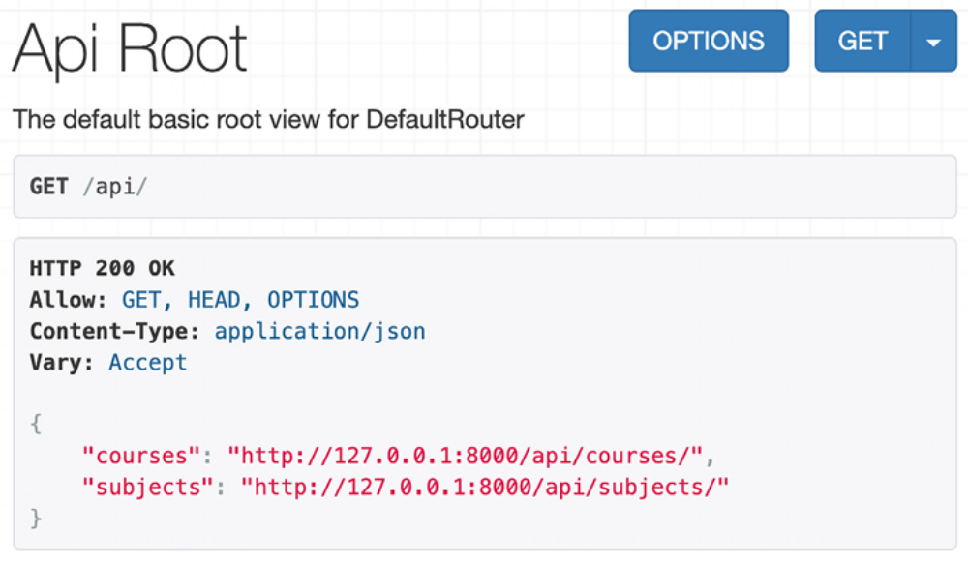
Figure 15.9: The API Root page of the REST framework browsable API

You can learn more about ViewSets at
https://www.django-res-tframework.org/api-guide/viewsets/. You can also find more
information about routers at
https://www.django-rest-framework.org/api-guide/routers/.

Generic API views and ViewSets are very useful to build REST APIs based on your models and serializers. However, you might also need to implement your own views with custom logic. Let’s learn how to create a custom API view.

Building custom API views
DRF provides an APIView class that builds API functionality on top of Django’s View class. The APIView class differs from View by using DRF’s custom Request and Response objects and handling APIException exceptions to return the appropriate HTTP responses. It also has a built-in authentication and authorization system to manage access to views.

You are going to create a view for users to enroll in courses. Edit the api/views.py file of the courses application and add the following code highlighted in bold:
from django.db.models import Count
from django.shortcuts import get_object_or_404
from rest_framework import generics
from rest_framework import viewsets
from rest_framework.response import Response
from rest_framework.views import APIView
from courses.api.pagination import StandardPagination
from courses.api.serializers import CourseSerializer, SubjectSer
from courses.models import Course, Subject
# ...
class CourseEnrollView(APIView):
def post(self, request, pk, format=None):
course = get_object_or_404(Course, pk=pk)
course.students.add(request.user)
return Response({'enrolled': True})

The CourseEnrollView view handles user enrollment in courses. The preceding code is as follows:

1. You create a custom view that subclasses APIView .

2. You define a post() method for POST actions. No other HTTP method will be allowed for this view.

3. You expect a pk URL parameter containing the ID of a course. You retrieve the course by the given pk parameter and raise a 404 exception if it’s not found.

4. You add the current user to the students many-to-many relationship of the Course object and return a successful response.

Edit the api/urls.py file and add the following URL pattern to the CourseEnrollView view:
path(
'courses/<pk>/enroll/',
views.CourseEnrollView.as_view(),
name='course_enroll'
),

Theoretically, you could now perform a POST request to enroll the current user in a course. However, you need to be able to identify the user and prevent unauthenticated users from accessing this view. Let’s see how API authentication and permissions work.

Handling authentication
DRF provides authentication classes to identify the user performing the request. If authentication is successful, the framework sets the authenticated User object in request.user . If no user is authenticated, an instance of Django’s AnonymousUser is set instead.

DRF provides the following authentication backends:

- BasicAuthentication : This is HTTP basic authentication. The user and password are sent by the client in the Authorization HTTP header, encoded with Base64. You can learn more about it athttps://en.wikipedia.org/wiki/Basic_access_authentication.

- TokenAuthentication : This is token-based authentication. A Token model is used to store user tokens. Users include the token in the Authorization HTTP header for authentication.

- SessionAuthentication : This uses Django’s session backend for authentication. This backend is useful for performing authenticated AJAX requests to the API from your website’s frontend.

- RemoteUserAuthentication : This allows you to delegate authentication to your web server, which sets a REMOTE_USER environment variable.

You can build a custom authentication backend by subclassing the BaseAuthentication class provided by DRF and overriding the authenticate() method.

Implementing basic authentication
You can set authentication on a per-view basis or set it globally with the DEFAULT_AUTHENTICATION_CLASSES setting.


Authentication only identifies the user performing the
request. It won’t allow or deny access to views. You have to
use permissions to restrict access to views.

You can find all the information about authentication at
https://www.django-rest-framework.org/apiguide/authentication/.

Let’s add BasicAuthentication to your view. Edit the api/views.py file of the courses application and add an authentication_classes attribute to CourseEnrollView , as follows:
# ...
from rest_framework.authentication import BasicAuthentication
class CourseEnrollView(APIView):
authentication_classes = [BasicAuthentication]
# ...

Users will be identified by the credentials set in the Authorization header of the HTTP request.
Adding permissions to views
DRF includes a permission system to restrict access to views. Some of the built-in permissions of DRF are:

- AllowAny : Unrestricted access, regardless of whether a user is authenticated or not.

- IsAuthenticated : Allows access to authenticated users only.

- IsAuthenticatedOrReadOnly : Complete access to authenticated users. Anonymous users are only allowed to execute read methods such as GET , HEAD , or OPTIONS .

- DjangoModelPermissions : Permissions tied to django.contrib.auth . The view requires a queryset attribute. Only authenticated users with model permissions assigned are granted permission.

- DjangoObjectPermissions : Django permissions on a per-object basis.

If users are denied permission, they will usually get one of the following HTTP error codes:

- HTTP 401 : Unauthorized

- HTTP 403 : Permission denied

You can read more information about permissions at
https://www.django-rest-framework.org/apiguide/permissions/.

Edit the api/views.py file of the courses application and add a permission_classes attribute to CourseEnrollView , as follows:
# ...
from rest_framework.authentication import BasicAuthentication
from rest_framework.permissions import IsAuthenticated
class CourseEnrollView(APIView):
authentication_classes = [BasicAuthentication]
permission_classes = [IsAuthenticated]
# ...

You include the IsAuthenticated permission. This will prevent anonymous users from accessing the view. Now, you can perform a POST request to your new API method.
Make sure the development server is running. Open the shell and run the
following command:
curl -i -X POST http://127.0.0.1:8000/api/courses/1/enroll/
You will get the following response:
HTTP/1.1 401 Unauthorized
...
{"detail": "Authentication credentials were not provided."}

You got a 401 HTTP code as expected, since you are not authenticated. Let’s use basic authentication with one of your users. Run the following command, replacing student:password with the credentials of an existing user:
curl -i -X POST -u student:password http://127.0.0.1:8000/api/cou

You will get the following response:
HTTP/1.1 200 OK
...
{"enrolled": true}

You can access the administration site and check that the user is now enrolled in the course.

Adding additional actions to ViewSets
You can add extra actions to ViewSets . Let’s change the CourseEnrollView view into a custom ViewSet action. Edit the api/views.py file and modify the CourseViewSet class to look as follows:
# ...
from rest_framework.decorators import action
class CourseViewSet(viewsets.ReadOnlyModelViewSet):
queryset = Course.objects.prefetch_related('modules')
serializer_class = CourseSerializer
@action(
detail=True,
methods=['post'],
authentication_classes=[BasicAuthentication],
permission_classes=[IsAuthenticated]
)
Def enroll(self, request, *args, **kwargs):
course = self.get_object()
course.students.add(request.user)
return Response({'enrolled': True})

In the preceding code, you add a custom enroll() method that represents an additional action for this ViewSet . The preceding code is as follows:

1. You use the action decorator of the framework with the parameter detail=True to specify that this is an action to be performed on a single object.

2. The decorator allows you to add custom attributes for the action. You specify that only the post() method is allowed for this view and set the authentication and permission classes.

3. You use self.get_object() to retrieve the Course object.

4. You add the current user to the students many-to-many relationship and return a custom success response.

Edit the api/urls.py file and remove or comment out the following URL,
since you don’t need it anymore:
path(
'courses/<pk>/enroll/',
views.CourseEnrollView.as_view(),
name='course_enroll'
),

Then, edit the api/views.py file and remove or comment out the CourseEnrollView class.

The URL to enroll on courses is now automatically generated by the router.
The URL remains the same, since it’s built dynamically using the action name enroll .

After students are enrolled in a course, they need to access the course’s content. Next, you are going to learn how to ensure only students who have enrolled can access the course.

Creating custom permissions
You want students to be able to access the contents of the courses they are enrolled on. Only students enrolled on a course should be able to access its contents. The best way to do this is with a custom permission class. DRF provides a BasePermission class that allows you to define the following methods:

- has_permission() : A view-level permission check

- has_object_permission() : An instance-level permission check

These methods should return True to grant access, or False otherwise.

Create a new file inside the courses/api/ directory and name it permissions.py . Add the following code to it:
from rest_framework.permissions import BasePermission
class IsEnrolled(BasePermission):
def has_object_permission(self, request, view, obj):
return obj.students.filter(id=request.user.id).exists()

You subclass the BasePermission class and override the has_object_permission() . You check that the user performing the request is present in the students relationship of the Course object. You are going to use the IsEnrolled permission next.

Serializing course contents
You need to serialize course contents. The Content model includes a generic foreign key that allows you to associate objects of different content models. Yet, you added a common render() method for all content models in the previous chapter. You can use this method to provide rendered content to your API.

Edit the api/serializers.py file of the courses application and add the following code to it:
from courses.models import Content, Course, Module, Subject
class ItemRelatedField(serializers.RelatedField):
def to_representation(self, value):
return value.render()
class ContentSerializer(serializers.ModelSerializer):
item = ItemRelatedField(read_only=True)
class Meta:
model = Content
fields = ['order', 'item']

In this code, you define a custom field by subclassing the RelatedField serializer field provided by DRF and overriding the to_representation() method. You define the ContentSerializer serializer for the Content model and use the custom field for the item generic foreign key.

You need an alternative serializer for the Module model that includes its contents, as well as an extended Course serializer. Edit the api/serializers.py file and add the following code to it:
class ModuleWithContentsSerializer(serializers.ModelSerializer):
contents = ContentSerializer(many=True)
class Meta:
model = Module
fields = ['order', 'title', 'description', 'contents']
class CourseWithContentsSerializer(serializers.ModelSerializer):
modules = ModuleWithContentsSerializer(many=True)
class Meta:
model = Course
fields = [
'id',
'subject',
'title',
'slug',
'overview',
'created',
'owner',
'modules'
]

Let’s create a view that mimics the behavior of the retrieve() action but includes the course contents. Edit the api/views.py file and add the following method to the CourseViewSet class:
# ...
from courses.api.permissions import IsEnrolled
from courses.api.serializers import CourseWithContentsSerializer
class CourseViewSet(viewsets.ReadOnlyModelViewSet):
# ...
@action(
detail=True,
methods=['get'],
serializer_class=CourseWithContentsSerializer,
authentication_classes=[BasicAuthentication],
permission_classes=[IsAuthenticated, IsEnrolled]
)
def contents(self, request, *args, **kwargs):
return self.retrieve(request, *args, **kwargs)

The description of this method is as follows:

1. You use the action decorator with the parameter detail=True to specify an action that is performed on a single object.

2. You specify that only the GET method is allowed for this action.

3. You use the new CourseWithContentsSerializer serializer class that includes rendered course contents.

4. You use both IsAuthenticated and your custom IsEnrolled permissions. By doing so, you make sure that only users enrolled in the course are able to access its contents.

5. You use the existing retrieve() action to return the Course object.

Open http://127.0.0.1:8000/api/courses/1/contents/ in your browser. If you access the view with the right credentials, you will see that each module of the course includes the rendered HTML for course contents, as follows:
{
"order": 0,
"title": "Introduction to Django",
"description": "Brief introduction to the Django Web Framework."
"contents": [
{
"order": 0,
"item": "<p>Meet Django. Django is a high-level
Python Web framework
...</p>"
},
{
"order": 1,
"item": "\n<iframe width=\"480\" height=\"360\"
src=\"http://www.youtube.com/embed/bgV39DlmZ2U?
wmode=opaque\"
frameborder=\"0\" allowfullscreen></iframe>\n"
}
]
}

You have built a simple API that allows other services to access the course application programmatically. DRF also allows you to handle creating and editing objects with the ModelViewSet class. We have covered the main aspects of DRF, but you will find further information about its features in its extensive documentation at
https://www.django-restframework.org/.

Consuming the RESTful API
Now that you have implemented an API, you can consume it in a programmatic manner from other applications. You can interact with the API using the JavaScript Fetch API in the frontend of your application, in a similar fashion to the functionalities you built in Chapter 6, Sharing Content on Your Website. You can also consume the API from applications built with Python or any other programming language.

You are going to create a simple Python application that uses the RESTful API to retrieve all available courses and then enroll a student in all of them. You will learn how to authenticate against the API using HTTP basic authentication and perform GET and POST requests.

We will use the Python Requests library to consume the API. We used Requests in Chapter 6, Sharing Content on Your Website, to retrieve images by their URL. Requests abstracts the complexity of dealing with HTTP requests and provides a very simple interface to consume HTTP services. You can find the documentation for the Requests library athttps://requests.readthedocs.io/en/master/.

Open the shell and install the Requests library with the following command: python -m pip install requests==2.31.0

Create a new directory next to the educa project directory and name it api_examples . Create a new file inside the api_examples/ directory and name it enroll_all.py . The file structure should now look like this:
api_examples/
enroll_all.py
educa/
...

Edit the enroll_all.py file and add the following code to it:
import requests
base_url = 'http://127.0.0.1:8000/api/'
url = f'{base_url}courses/'
available_courses = []
while url is not None:
print(f'Loading courses from {url}')
r = requests.get(url)
response = r.json()
url = response['next']
courses = response['results']
available_courses += [course['title'] for course in courses]
print(f'Available courses: {", ".join(available_courses)}')

In this code, you perform the following actions:

1. You import the Requests library and define the base URL for the API and the URL for the course list API endpoint.

2. You define the available_courses empty list.

3. You use a while statement to paginate over all result pages.

4. You use requests.get() to retrieve data from the API by sending a GET request to the URL http://127.0.0.1:8000/api/courses/ . This API endpoint is publicly accessible, so it does not require any authentication.

5. You use the json() method of the response object to decode the JSON data returned by the API.

6. You store the next attribute in the url variable to retrieve the next page of results in the while statement.
7. You add the title attribute of each course to the available_courses list.

8. When the url variable is None , you go to the latest page of results and you don’t retrieve any additional pages.

9. You print the list of available courses.

Start the development server from the educa project directory with the following command:
python manage.py runserver

In another shell, run the following command from the api_examples/ directory:
python enroll_all.py

You will see output with a list of all course titles, like this:
Available courses: Introduction to Django, Python for beginners,

This is the first automated call to your API.
Edit the enroll_all.py file and add the following lines highlighted in bold:
import requests
username = ''
password = ''
base_url = 'http://127.0.0.1:8000/api/'
url = f'{base_url}courses/'
available_courses = []
while url is not None:
print(f'Loading courses from {url}')
r = requests.get(url)
response = r.json()
url = response['next']
courses = response['results']
available_courses += [course['title'] for course in courses]
print(f'Available courses: {", ".join(available_courses)}')
for course in courses:
course_id = course['id']
course_title = course['title']
r = requests.post(
f'{base_url}courses/{course_id}/enroll/',
auth=(username, password)
)
if r.status_code == 200:
# successful request
print(f'Successfully enrolled in {course_title}')

Replace the values for the username and password variables with the credentials of an existing user, or load the values from environment variables. You can use python-decouple , as we did in the Working with environment variables section in Chapter 2, Enhancing Your Blog and Adding Social Features, to load credentials from environment variables.

With the new code, you perform the following actions:

1. You define the username and password of the student you want to enroll in courses.

2. You iterate over the available courses retrieved from the API.

3. You store the course ID attribute in the course_id variable and the title attribute in the course_title variable.

4. You use requests.post() to send a POST request to the URL http://127.0.0.1:8000/api/courses/[id]/enroll/ for each course. This URL corresponds to the CourseEnrollView API view, which allows you to enroll a user in a course. You build the URL for each course using the course_id variable. The CourseEnrollView view requires authentication. It uses the IsAuthenticated permission and the BasicAuthentication authentication class. The Requests library supports HTTP basic authentication out of the box. You use the auth parameter to pass a tuple with the username and password to authenticate the user, using HTTP basic authentication.

5. If the status code of the response is 200 OK , you print a message to indicate that the user has been successfully enrolled in the course.

You can use different kinds of authentication with Requests. You can find more information on authentication with Requests at
https://requests.readthedocs.io/en/master/user/authentication/.

Run the following command from the api_examples/ directory:
python enroll_all.py

You will now see output like this:
Available courses: Introduction to Django, Python for beginners,
Successfully enrolled in Introduction to Django
Successfully enrolled in Python for beginners
Successfully enrolled in Algebra basics

Great! You have successfully enrolled the user in all available courses using the API. You will see a Successfully enrolled message for each course on the platform. As you can see, it’s very easy to consume the API from any other application.

Summary
In this chapter, you learned how to use DRF to build a RESTful API for your project. You created serializers and views for models, and you built custom API views. You also added authentication to your API and restricted access to API views using permissions. Next, you discovered how to create custom permissions, and you implemented ViewSets and routers. Finally, you used the Requests library to consume the API from an external Python script.

The next chapter will teach you how to build a chat server using Django Channels. You will implement asynchronous communication using WebSockets, and you will use Redis to set up a channel layer.

Additional resources
The following resources provide additional information related to the topics
covered in this chapter:
Source code for this chapter: ( See page 1014 )

